# 예제1] part03/ex01_exploratory_analysis.py

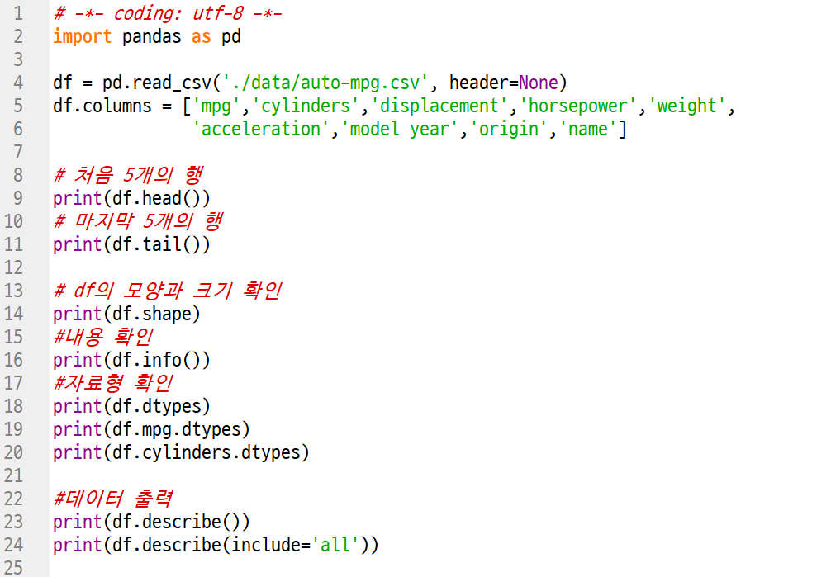

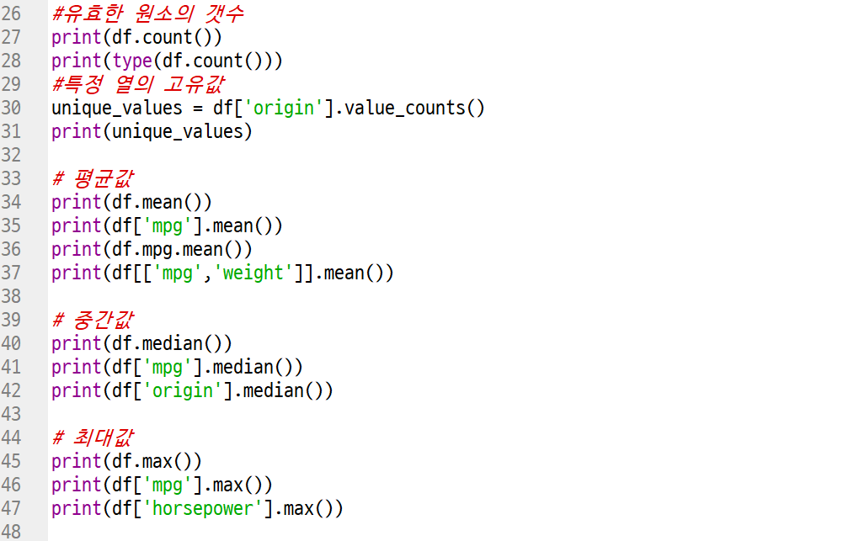

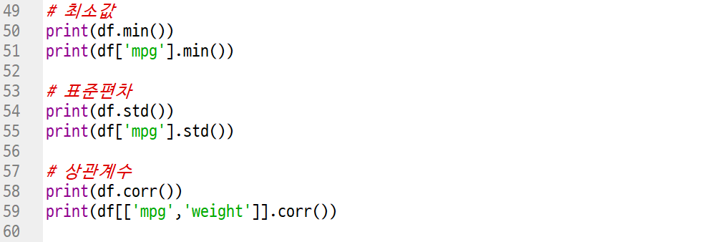

# 예제2] part03/ex02_df_plot.py

pip install openpyxl

pip install matplotlib

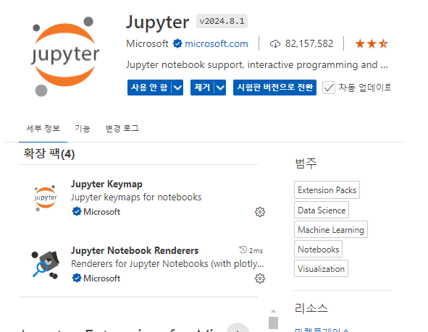

설치할 것

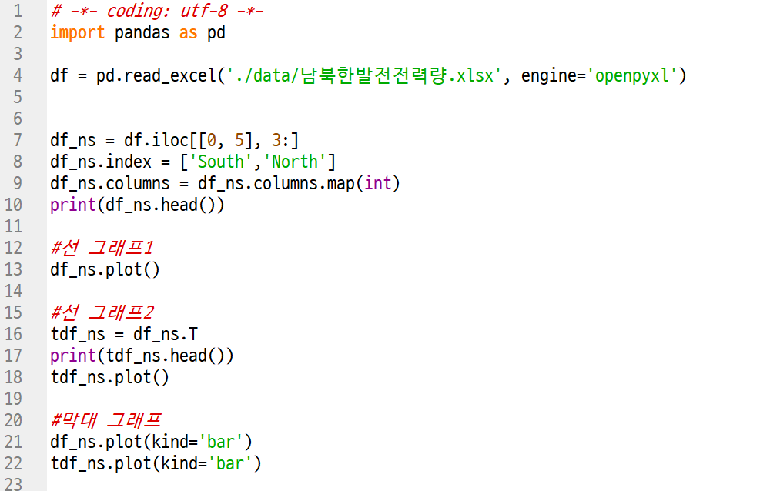

예제3] part03/ex03_df_plot_scatter.py

